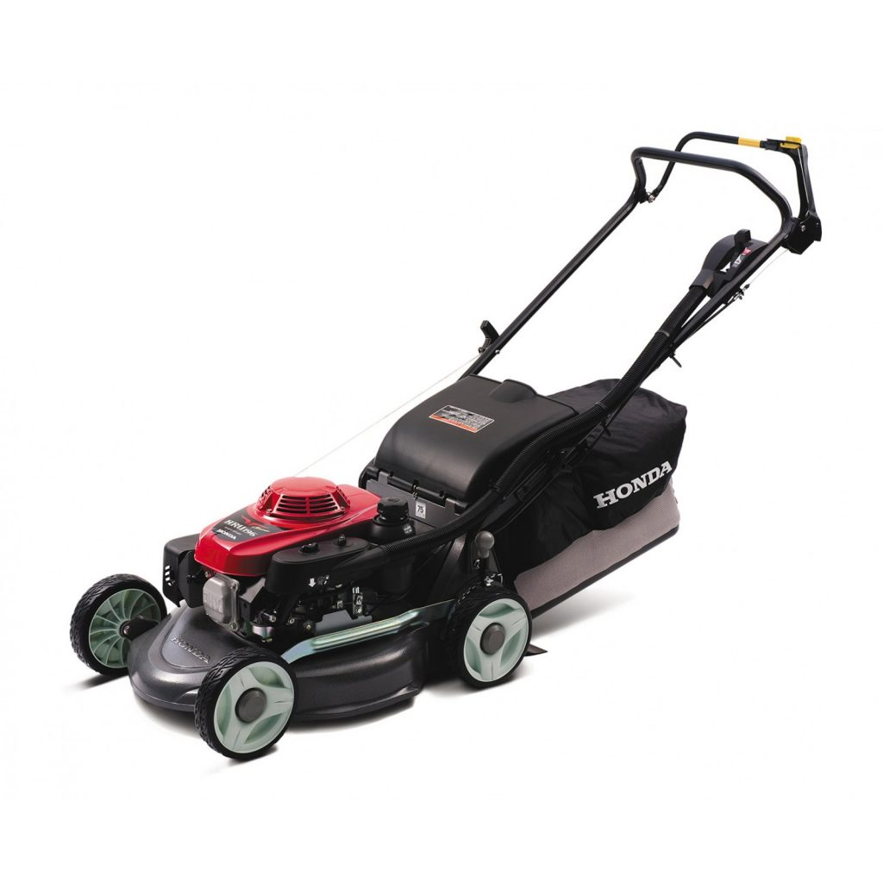

**Domestic Motor Mower – Instructions for use**

**PRE-START CHECKS:**

* Secure handle position with locking knobs.
* Set cutting height.
* Fit catcher if required.
* Check the area for debris eg wire, stones etc.
* Check that all guards are in place and the catcher is properly attached.

**STARTING PROCEDURE:**

* Engage choke (cold start).
* Hold mower steady with one hand & engage safety/dead man lever.
* Grasp starter pull cord and pull evenly.
* When engine starts move throttle to run position.
* Disengage choke.

**OPERATION:**

* When catcher is full, turn off mower & empty.
* Do not leave engine running while unattended.
* If vibration occurs stop immediately.

**STOPPING AND AFTER USE:**

* Move throttle control to idle.
* Release safety lever.
* Remove catcher.
* Allow to cool down.
* Remove bulk of clippings from under carriage and catcher.

**SAFETY PRECAUTIONS:**

* Keep children away.
* Do not empty catcher while motor is running.
* Do not clean out grass with hands while engine is running.
* Keep hands and feet clear of mower.

**REQUIRED SAFETY EQUIPMENT**