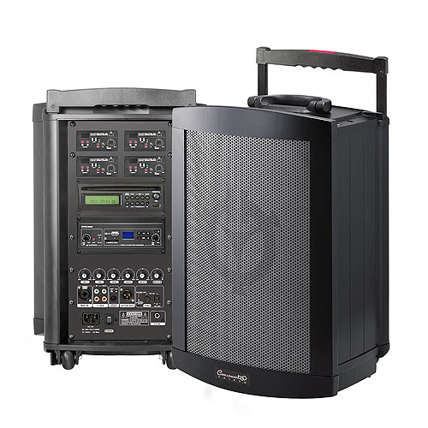

**PA System 17 – Instructions for use**

**PRE-START CHECKS**

Ensure you have everything required to use the PA System (1 Speaker, 1 Tripod, 2 Wireless Microphones, 1 Remote Control, 1 Power Cord, 1 RCA to 3.5mm Cable) & there is no damage to anything.

**STARTING PROCEDURE**

Plug power cords in & turn power on and do a sound check ensuring mics work.

Connect aux cord to a device of your choice.

**OPERATION**

Once everything is on and working. Select the option you require (cd, aux or mics)

**STOPPING AND AFTER USE**

Power is switched off at wall

Everything is placed securely in the carry case