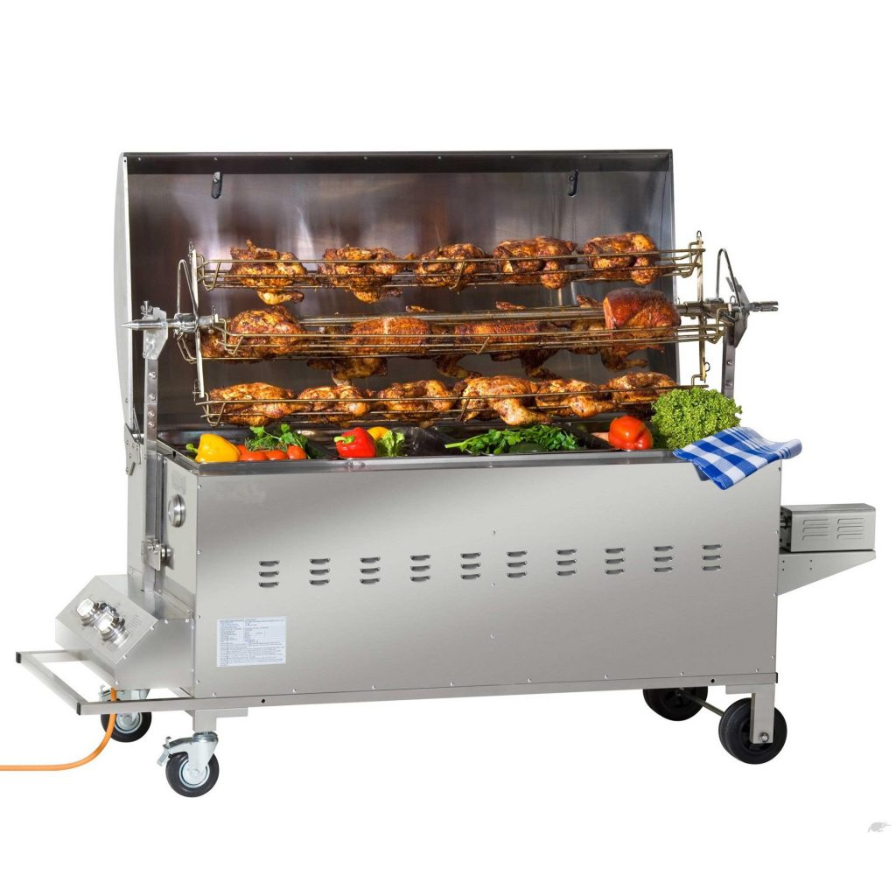
Spit Roaster – Instructions for use

PRE-START CHECKS
Ensure you have a full 9kg LPG gas bottle with the correct regulator.
The gas bottle must be positioned on a flat level ground when in use with the spit roaster.
The hose must hang freely with no bends or twisting that could obstruct free flow gas.

STARTING PROCEDURE
1.Open the hood of the oven before attempting to light the burners & remove the 4 stainless steel trays.
2. Turn all control knobs to OFF position.
3. Connect the regulator to gas bottle & turn gas supply on.
4. On one of the two burners, push in the control knob and turn it anti clockwise to HIGH position, at the same time hold the ignition button (a clicking sound will be heard) this will light the burner. Keep pressing in the knob for a further 15 seconds after ignition. Release control knob and observe that the burner has remained alight. If not, repeat this process. Then repeat for the second burner if required.
5. If the burner has not lit after retrying, wait 5 minutes & repeat step 4.
6. Adjust the heat by turning the knob to the low/high position.

STOPPING AND AFTER USE
To turn the burner OFF, turn the control knob clockwise to the OFF position.
If you wish to turn the complete appliance off turn the cylinder valve to the closed position and then turn the cylinder valve to the closed position and then turn the control knob on the appliance clockwise to the OFF position on both burners

SAFETY PRECAUTIONS
This spit roaster is for outdoor use only
Use this spit roaster on a flat, stable surface
Accessible parts may be hot, always use oven gloves & bbq tools with long heat resistant handles – keep young children away.
Do not move the appliance during use
Never leave unattended when lit & in use
Never light burners with hood in closed position
Control panel, rotisserie & motor MUST NOT be exposed to water, dap conditions or used when raining.

COOKING GUIDELINES
Balancing the food
In rotisserie cooking, this requires the most attention. The rotisserie must turn evenly otherwise the stopping & starting action will cause the food to cook unevenly and possibly burn the heavier side.

The easiest foods to balance are those of uniform shape & texture. To test if the food is balanced correctly when secured, place the ends of the rotisserie skewer loosely in the palms of your hands. If there is no tendency to roll, give the spit a quarter turn. If it’s still stable give it a final quarter turn. It should rest without turning in each of these positions. It can then be attached to the spit roaster.

The maximum carcass weight allowed is 50kg. Ensure that the carcass is held firmly using with sets of prongs and the leg braces.
Cooking time will vary according to the type and weight of food you are cooking.
Monitor the meat closely at all times
CLEANING
After the food is cooked & while the roaster is still semi warm, wash out with warm water. Take off as much grease and fat etc as you can.
Wipe down with a towel until it is nice & clean.
FAIL TO DO THIS & YOU MAY INCURR A CLEANING CHARGE AND LOSS OF BOND.

